國際佛光會世界總會
Buddha's Light International Association, World Headquarters
3456 S. Glenmark Drive, Hacienda Heights, CA 91745, U.S.A.
Tel:1-626-968-4675~77 Fax:1-626-968-1255 E-mail: info@blia.org http://www.blia.org

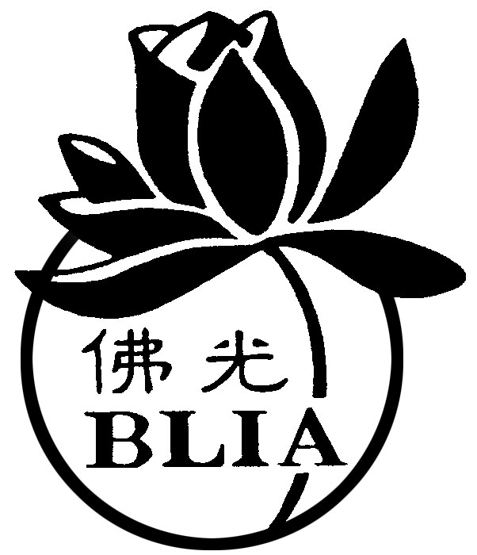
NGO in Special Consultative Status with the Economic and Social Council of the United Nations
NGO associated with the Department of Public Information of the United Nations

(17) 佛光世心字第003號
World Headquarters Memorandum
To: | BLIA World Headquarters Directors, Committee Directors and Deputy Directors, Lay Dharma Lecturers, Elder Advisors, Presidents of Chapter, and Monastic Advisors
From: | Most Venerable Hsin Bao  President, BLIA World Headquarters
Date: | April 14, 2017
Subject: | BLIA World Headquarters 3rd Meeting of the Sixth Board of Directors and the inauguration of Hsing Ma Temple will be held at Hsing Ma Temple in Malaysia on October 4-8, 2017. Chapters are cordially invited to participate in the meeting, sharing in the Dharma benefits.
Description: | - Attached is the “2017 BLIA World Headquarters 3rd Meeting of the Sixth Board of Directors Application” and “Pre/Post-Meeting Tours” for reference.  - Schedule of the Meeting Activities:
10/04 Afternoon 3:00 PM Arrive at Hsing Ma Temple for registration
Evening Welcome Banquet
10/05~07 Opening Ceremony/ Hsing Ma Temple Inauguration/
Motion Discussion
Certification/ Group Discussion/ Night of Buddha’s Light
10/08 Noon Closing Ceremony
Afternoon Chan and Pure Land Light-offering Ceremony
10/09 Farewell

Wishing you all a rising dawn of success!

